Lab # 05: Programming in PHP



**Spring 2023**

**Data Base Management System Lab**

**Submitted by:**

Maaz Habib

**Registration No.:**

20PWCSE1952

**Class Section:**

C

“On my honor, as student of University of Engineering and Technology, I have neither given nor received unauthorized assistance on this academic work.”

**Submitted to:**

Sumayyea Salahuddin

Department of Computer Systems Engineering

# University of Engineering and Technology, Peshawar

# **---------------------------Task 5.1---------------------------**

**In contrast to settype(), there is another method that causes a variable’s value to be treated as a specific type. It is known as type casting. Note that the variable itself remains unaffected during type casting. Consider the following variable:**

**• $test_var = 8.23;**

**Type cast this variable’s value to integer, string, and Boolean and show result using echo.**

**Code:**

<!DOCTYPE html>

<html>

<body>

<h1>PHP page</h1>

<?php

$test_var =2.589 ;

// Type cast to string

$string_var = (string) $test_var;

echo "As string: $string_var <br>";

// Type cast to integer

$int_var = (int) $test_var;

echo "As integer: $int_var <br>";

// Type cast to boolean

$bool_var = (bool) $test_var;

echo "As boolean: $bool_var <br>";

?>

</body>

</html>

**OutPut:**

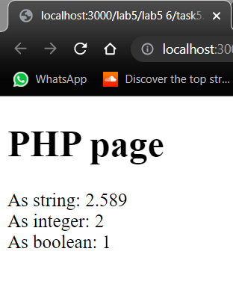

# **---------------------------Task 5.2---------------------------**

**Use and Specify the purpose of following functions:**

1. **intval( value )**
2. **floatval( value )**
3. **strval( value )**

**Code:**

<!DOCTYPE html>

<html>

<body>

<h1>Task 2</h1>

<?php

$value1 = "2002";

$value2 = 2.789;

$value3 = true;

// Using intval function to convert a string to an integer

$int_value1 = intval($value1);

echo "Integer value of $value1 is $int_value1 <br>";

// Using floatval function to convert a value to a float

$float_value2 = floatval($value2);

echo "Float value of $value2 is $float_value2 <br>";

// Using strval function to convert a value to a string

$str_value3 = strval($value3);

echo "String value of $value3 is $str_value3 <br>";

?>

</body>

</html>

**Output:**

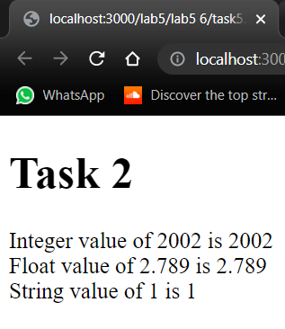

# **---------------------------Task 5.3---------------------------**

Write PHP script that shows the division table displayed as in Table 5.2 using different loops. For each number, display whether that number is an odd or even number, and also display a message if the number is a prime number. Display this information within an HTML table.

**Code:**

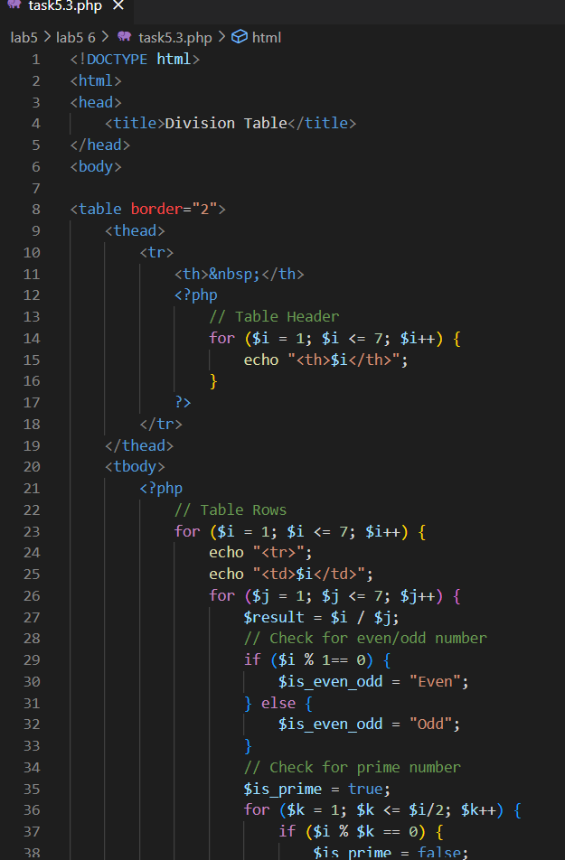

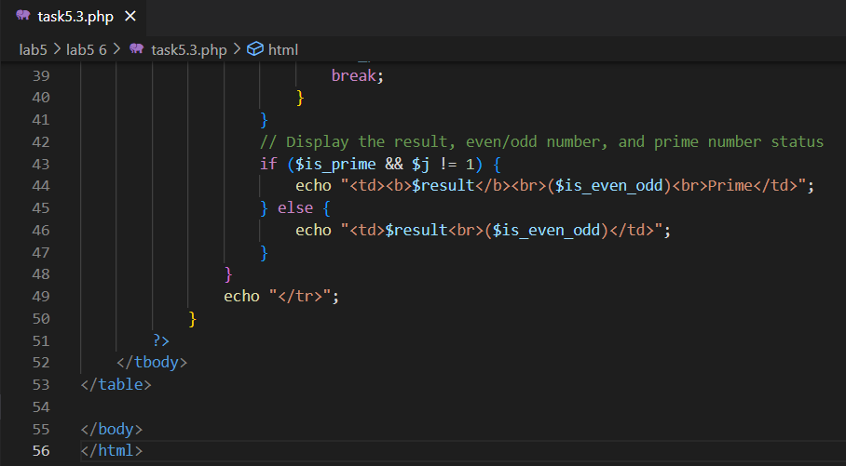

**Output:**

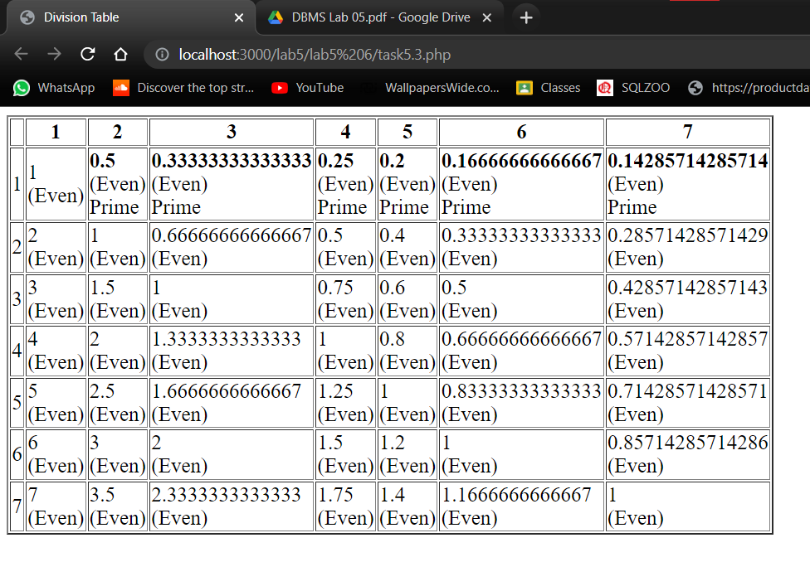

# **---------------------------Task 5.4---------------------------**

Explore PHP Object Oriented using examples showing classes, objects, inheritance, and polymorphism.

**Classes:**

**Code:**

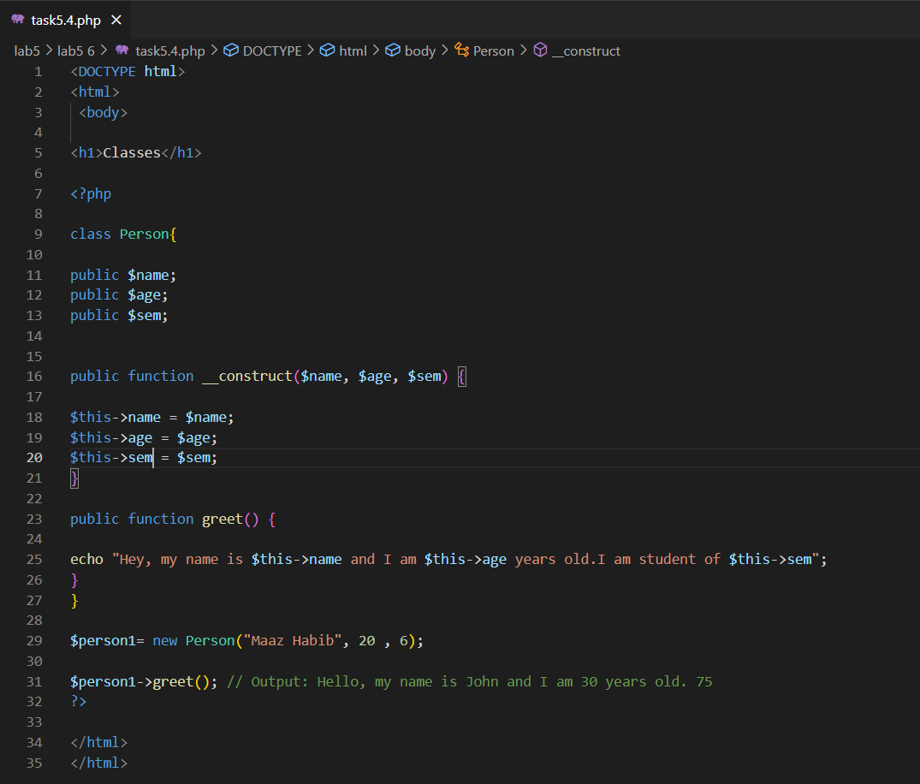

**Output:**

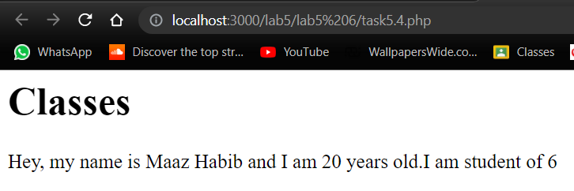

**Inheritance:**

**Code:**

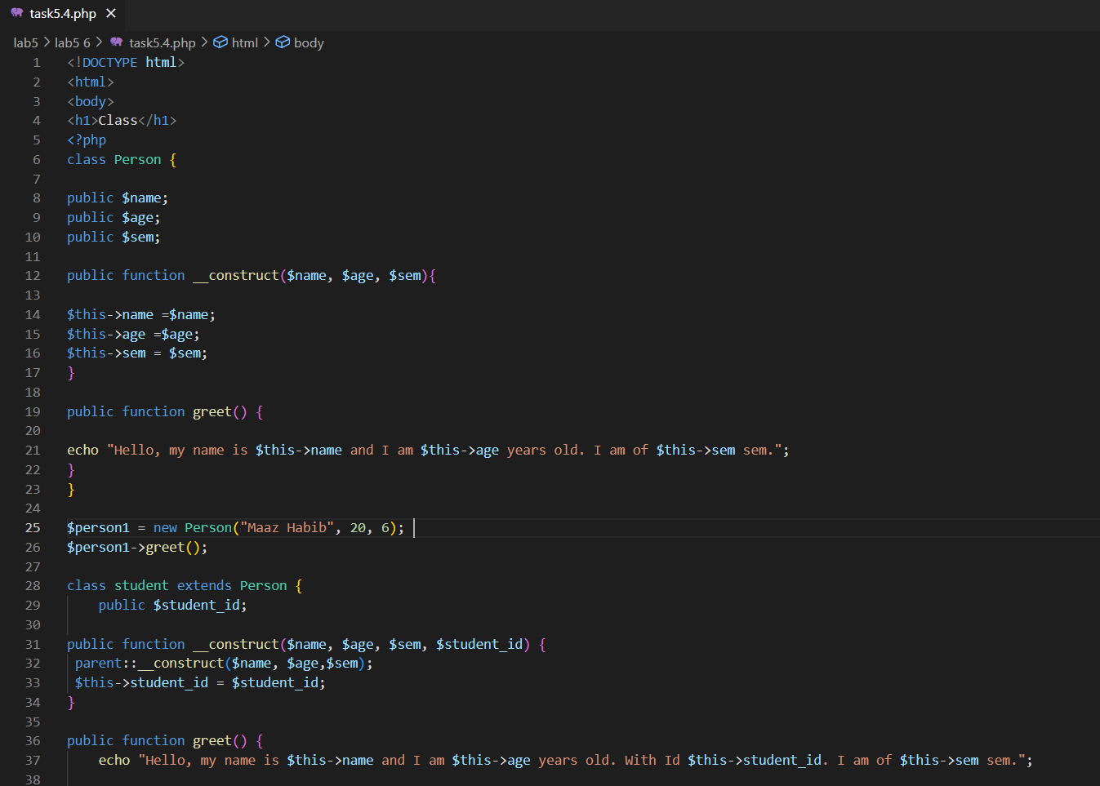

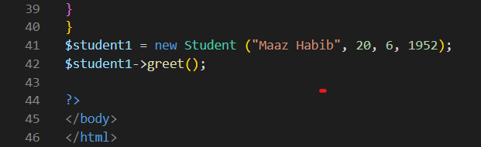

**Output:**

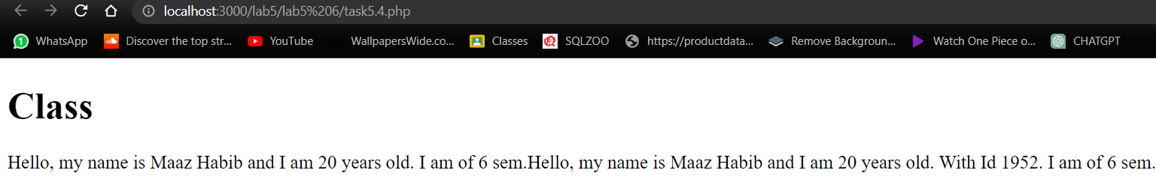

**Polymorphism:**

**Code:**

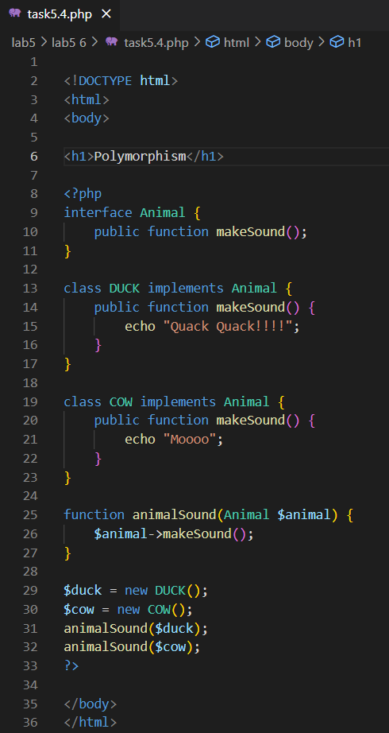

**Output:**

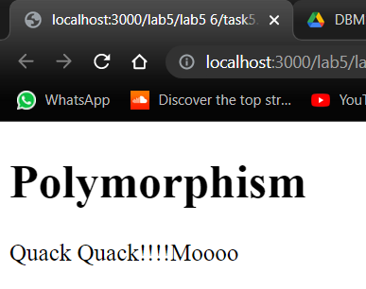

# **---------------------------Task 5.5---------------------------**

Build an image gallery website using PHP without database. Your website must show all the images in a given directory. Use bootstrap/CSS in your website. Please note that when a given image is clicked, it enlarges it and shows in higher resolution. Also, your website should be flexible enough to show the images when number of images are increased or decreased from a given directory.

**Code:**

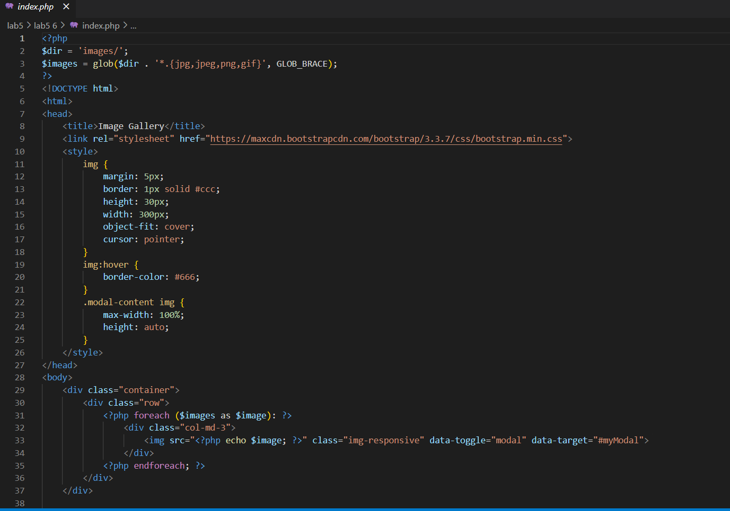

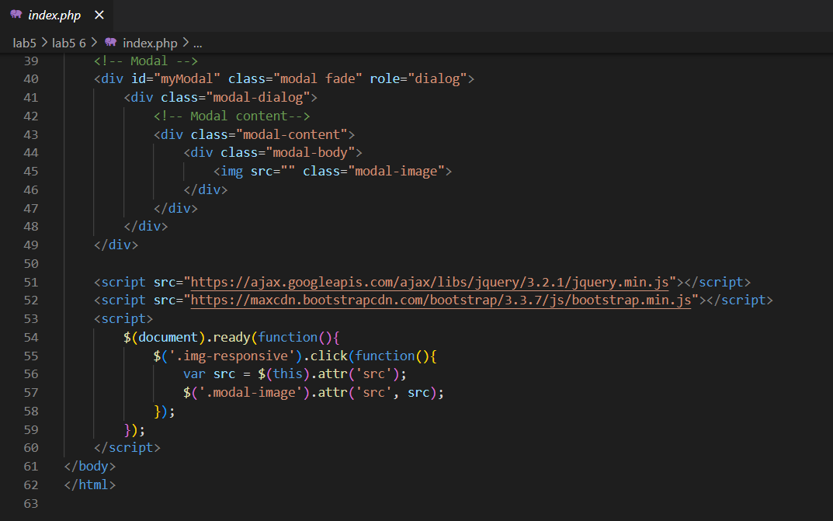

**Output:**

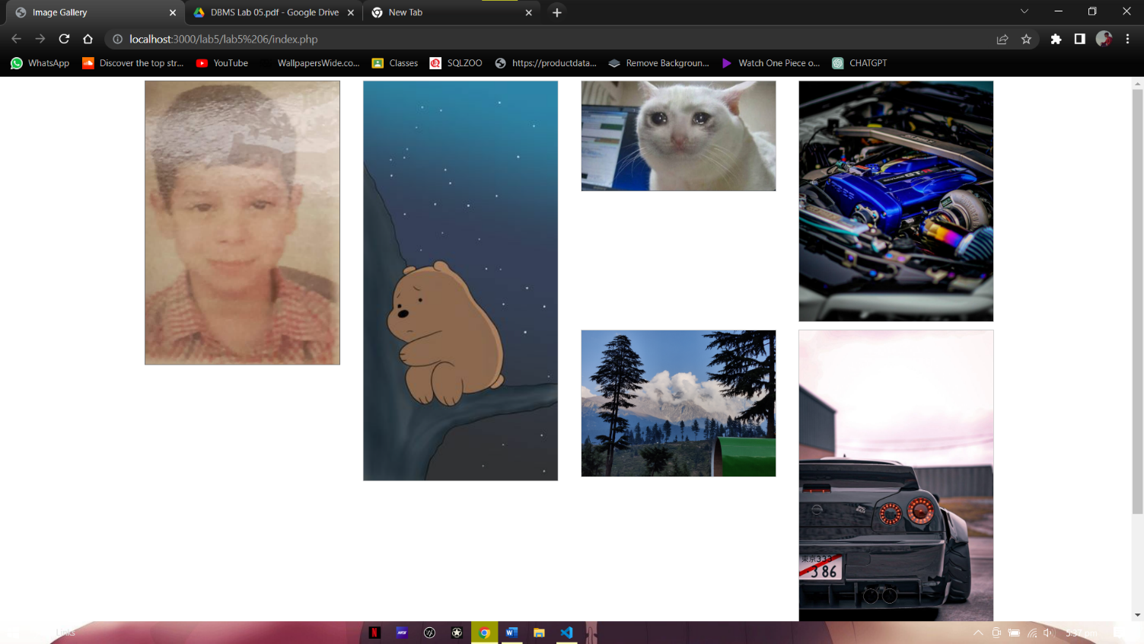

# ---------------------------Task 5.6---------------------------

Tutorial on PHP MVC Framework: LARAVEL.

**Composer:**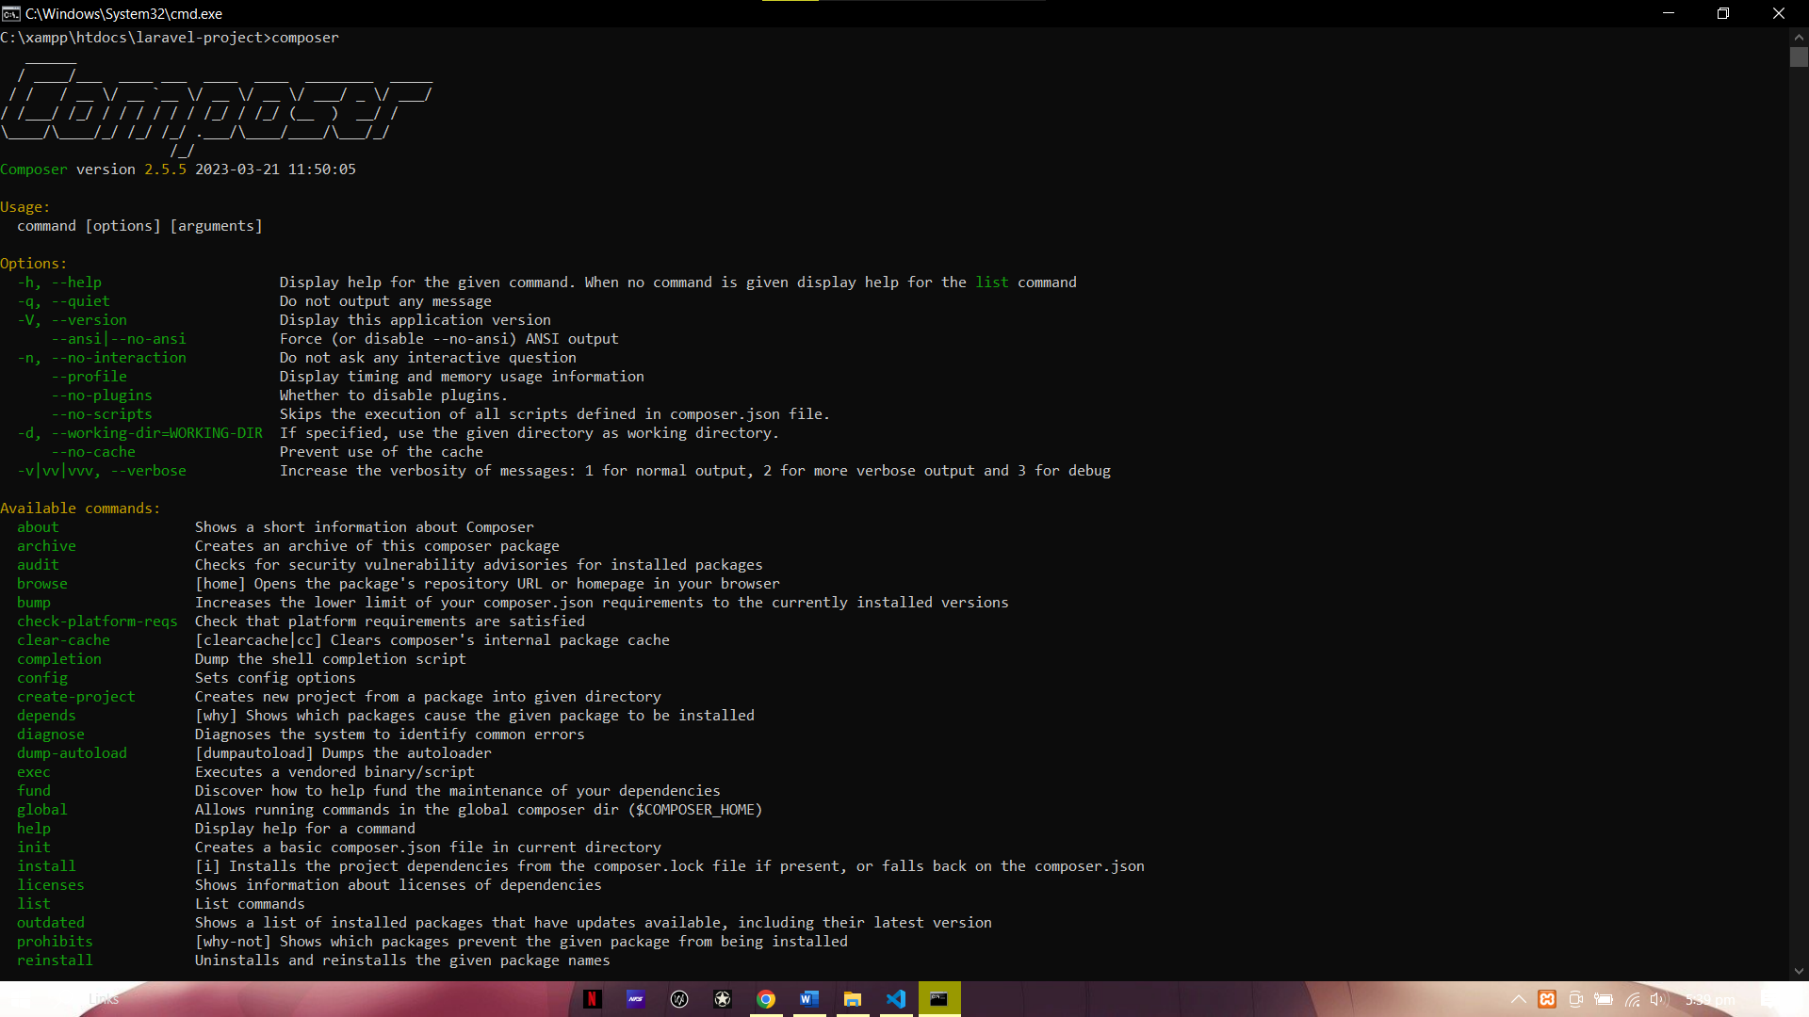

**Project create:**

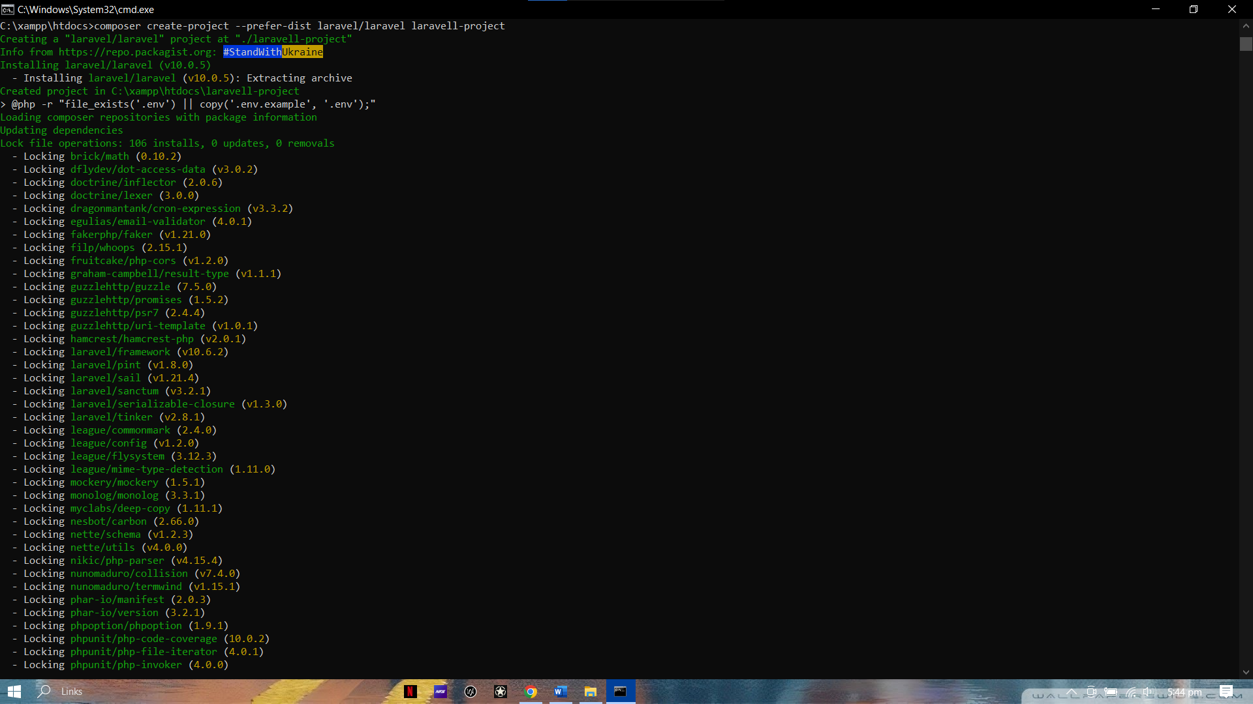

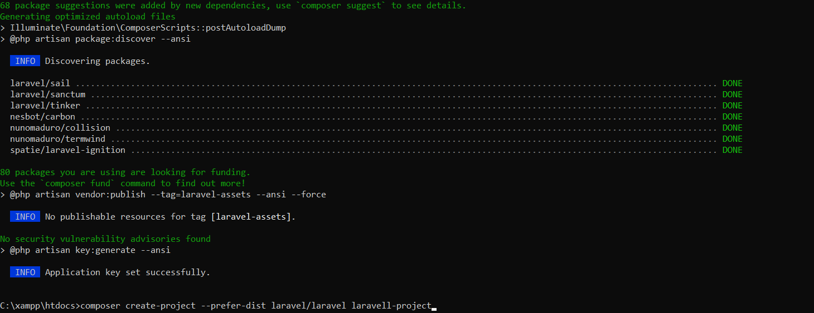

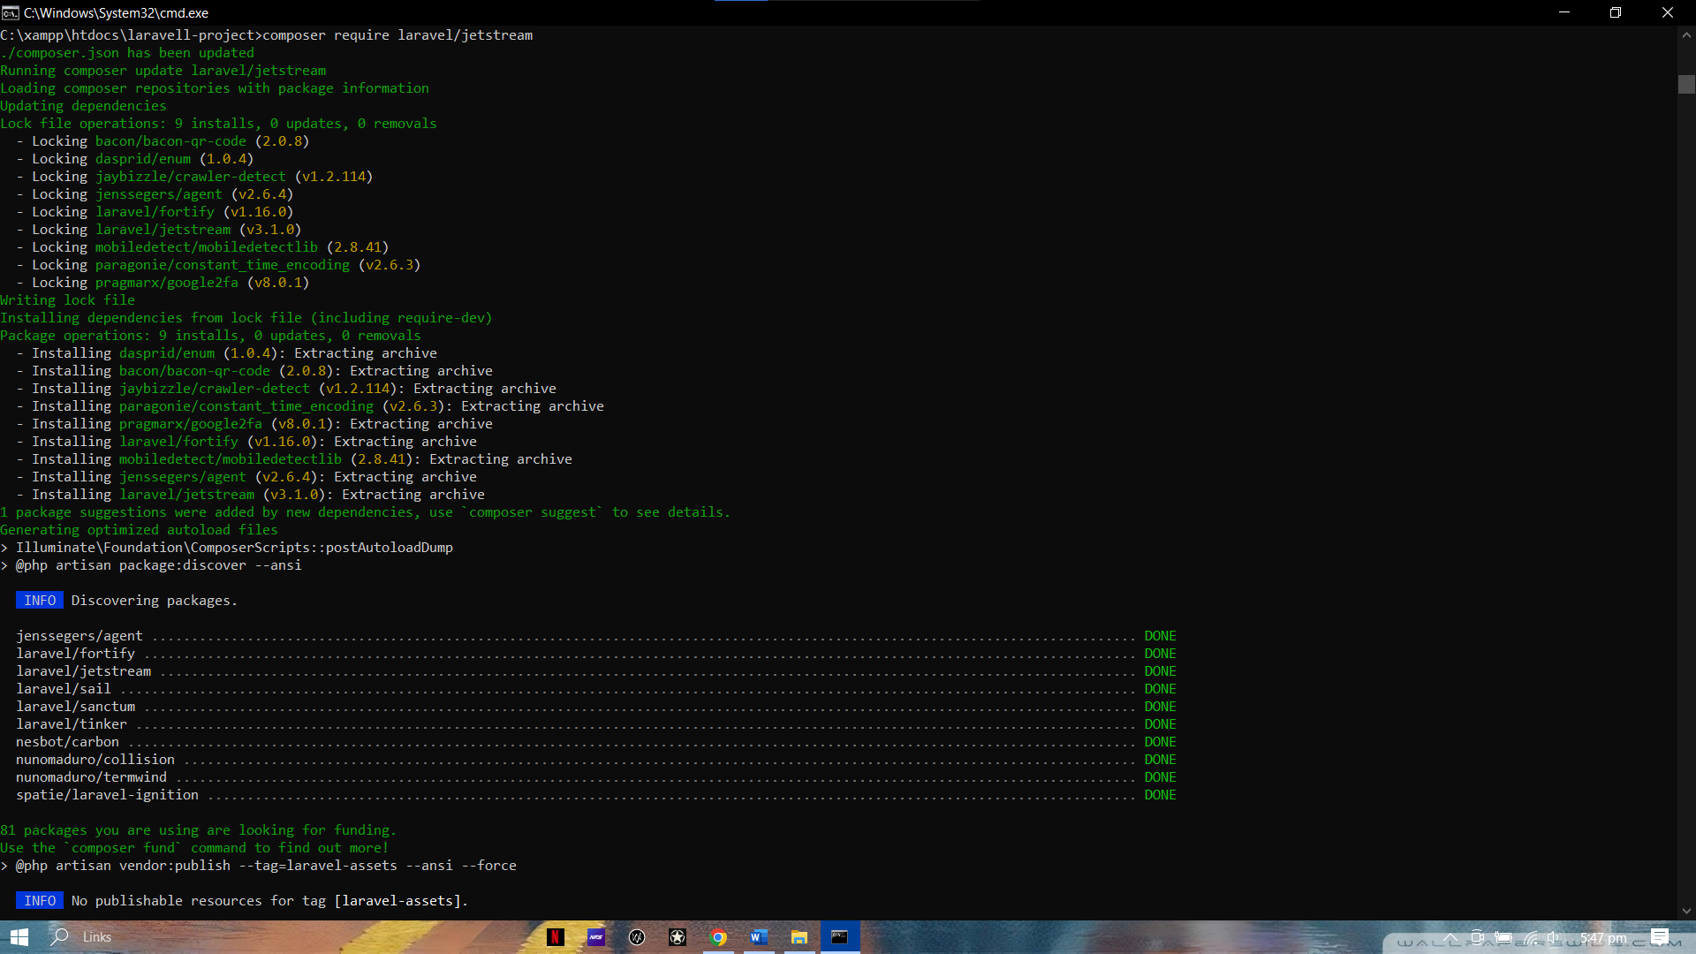

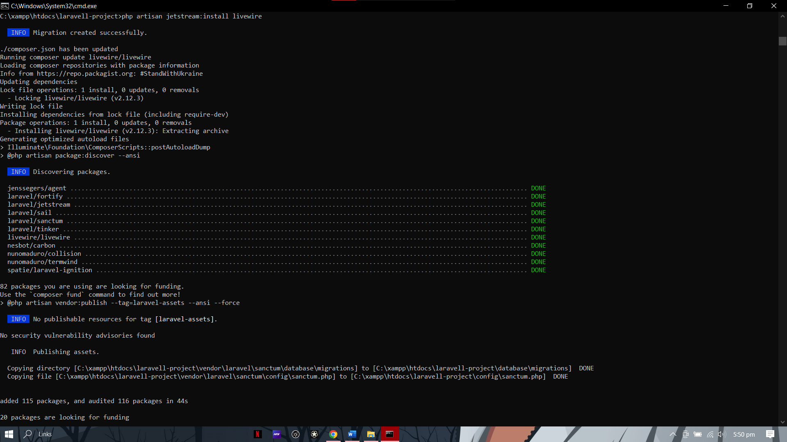

**Running the serve:**

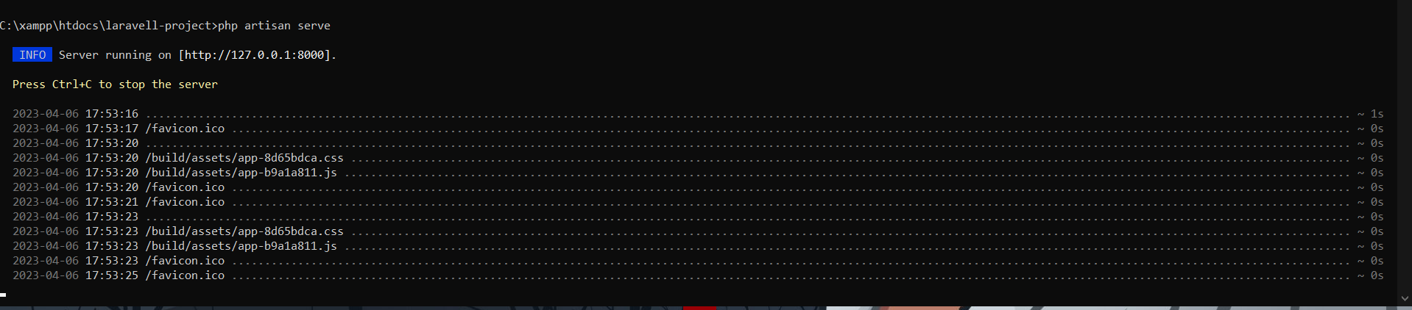

**Output:**

**Main page:**



**Login:**

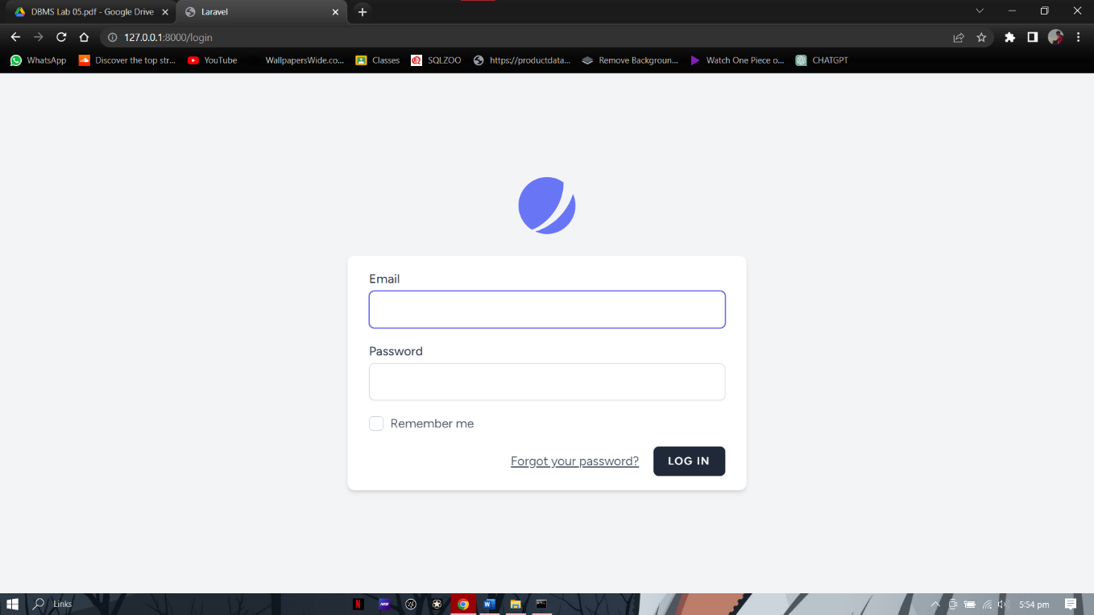

**Registration:**

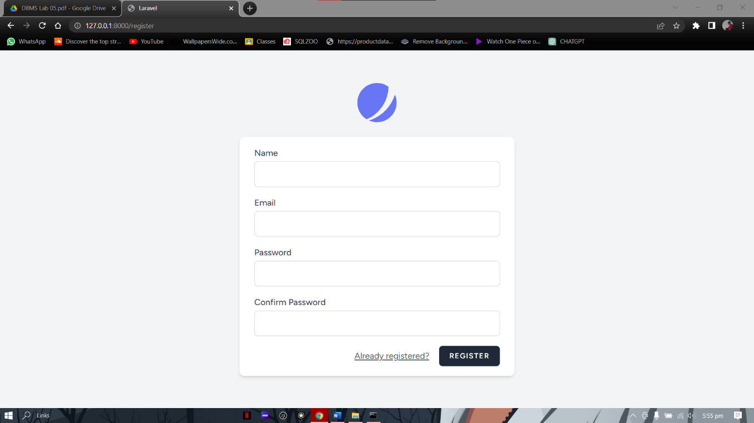

**After registration:**

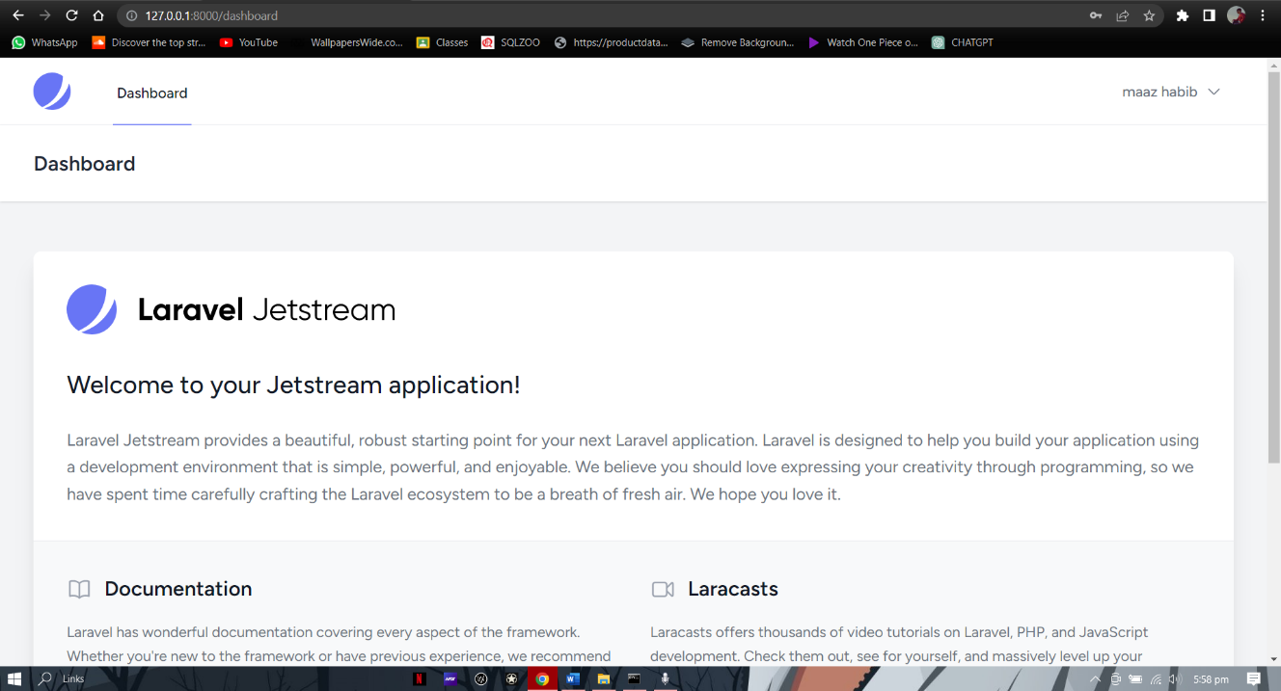

# **---------------------------Task 5.7---------------------------**

Implement the following relationship in Laravel.

Department: depID, depName

Emplyee: empID, empName, empJob, dID

Note that the department has at least one or many employees working in it; while employee works exactly in one department. Also, feed atleast five records in the created tables.